**Test report - Deployment of Arktos Cluster without Mizar**  **CNI on AWS**  **(Community code)**

This document captures the steps to deploy an Arktos cluster lab without Mizar CNI. The machine in this lab used are **t2.2xlarge, 128 GB storage and Ubuntu 18.04 LTS.**

Date-31 Dec. 2021

# Step-1: Update kernel (If required)

To check kernel, run following command

uname -a



|  |  |
| --- | --- |
| wget https://raw.githubusercontent.com/CentaurusInfra/mizar/dev-next/kernelupdate.sh | |
| sudo bash kernelupdate.sh |  |



# Step-2: Install dependencies

Run the following steps to install dependencies required for arktos deployment: sudo mkdir -p $GOPATH/src/github.com

cd $GOPATH/src/github.com

sudo git clone <https://github.com/CentaurusInfra/arktos>

cd arktos

sudo bash hack/setup-dev-node.sh

export PATH=$PATH:/usr/local/go/bin

sudo -i

cd $GOPATH/src/github.com/arktos

make

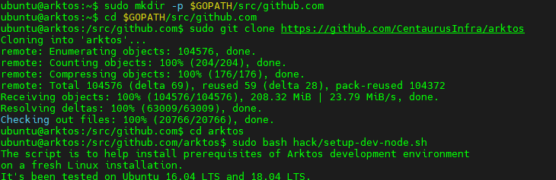

**Run Arktos**

The easiest way to run Arktos is to bring up a single-node cluster in your local development box:

hack/arktos-up.sh

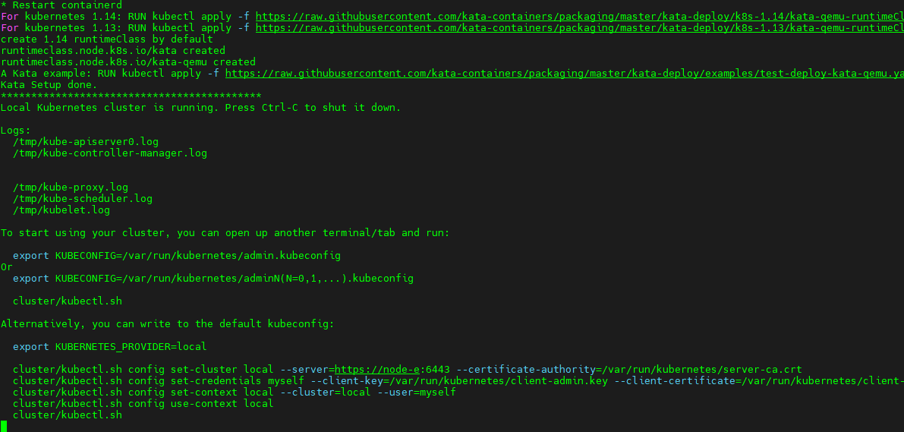

1. **Check nodes status:**

./cluster/kubectl.sh get nodes

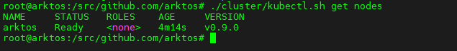

1. **Check pods status:**

./cluster/kubectl.sh get pods -Ao wide

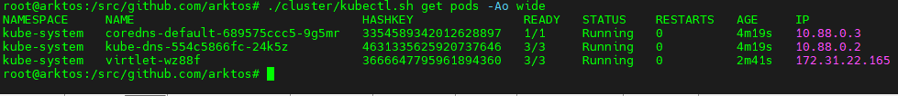

**Deploy test pods**:

**Command:**

./cluster/kubectl.sh apply -f <https://github.com/Click2Cloud-Centaurus/Documentation/blob/main/test-yamls/test_pods.yaml>

**Check deployed pods:**

**Command:**

./cluster/kubectl.sh get pods -Ao wide

**Output**

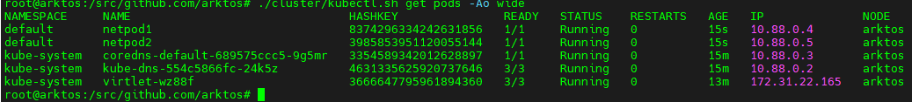

**Check ping deployed pods:**

**Command:**

./cluster/kubectl.sh exec -it netpod1 ping 10.88.0.5

./cluster/kubectl.sh exec -it netpod2 ping 10.88.0.4

**Output:**

